**IOT BASED AUTOMATIC BELL SYSTEM WITH MOBILE APPLICATION**

**SITHAMPARAPILLAI KATHEESKUMAR**

**REGISTRATION NUMBER: BAT/IT/2018/FT/030**

**ATI - BATTICALOA**

**SRI LANKA INSTITUTE OF ADVANCED TECHNOLOGICAL EDUCATION**

**2020**

**IOT BASED AUTOMATIC BELL SYSTEM WITH MOBILE APPLICATION**

**SITHAMPARAPILLAI KATHEESKUMAR**

**REGISTRATION NUMBER: BAT/IT/2018/FT/030**

A Software project is submitted to the Department of Information Technology, ATI Batticaloa in Partial Fulfillment of the Requirements of the Degree of Higher National Diploma in Information Technology.

**ATI - BATTICALOA**

**SRI LANKA INSTITUTE OF ADVANCED TECHNOLOGICAL EDUCATION**

**2020**

**CERTIFICATION**

This is to certify that the project entitled **“**IOT BASED AUTOMATIC BELL SYSTEM WITH MOBILE APPLICATION**”** submitted by SITHAMPARAPILLAI KATHEESKUMAR, Registration Number: **BAT/IT/2018/FT/030** to the Faculty of IT, ATI Batticaloa, in Partial Fulfillment of the Requirements of the Higher National Diploma in Information Technology is his original work based on the study carried out independently by her during the period of study under my guidance, supervision and approved for submission.

…………………………………..

Signature of the Supervisor,

Mr. P. PIRAPURAJ,

Lecturer in Information Technology,

South Eastern University of Sri Lanka.

Date: ………………………………..

**DECLARATION**

I do hereby declare that the work reported in this project report was exclusively carried out by me under the supervision of Mr.P.Pirapuraj Lecturer of the Department of Information Technology. It describes the result of my own and independent work except where due reference has been made in the text. No part of this project report has been submitted earlier or concurrently for the same or any other diploma.

Name: S. KATHEESKUMAR

Reg.no: BAT/IT/2018/FT/030

Supervisor: ………………………….............. Date: ……………

Signature: ……………………

Head of the Department: ...................................

Date: ………………………

Signature: ................................…

**ACKNOWLEDGEMENT**

The success and final outcome of this project required a lot of guidance and assistance from many people and my extremely fortunate to have got this all along the completion of this project work. Whatever I have done is only due to such guidance and assistance and I would not forget to thank them. I respect and thank our project supervisor Mr.S.Jayapalan sir and other lecturers for giving me an opportunity to do this project work and providing me all support and guidance which made me complete the project on time, I extremely grateful to him for providing such a nice support and guidance.

I am really grateful because I could manage to complete this project within the time given by. This project cannot be completed without the effort and co-operation from my friends. I would like to express my gratitude to my friends and respondents for support and willingness to spend some time with me.

Thank you

**ABSTRACT**

IOT based Bell is a smart, affordable device that helps you manage school bells via smartphone. It also saves your time, effort, and maintains excellent accurate timing and provides security as well.

You’ll receive notifications when bells are added to your school physical electric bell, and you’ll be able to keep track of your school bell. In order to improve the belling system of BT/Kannankudah Maha Vidyalaya, the implementation phase is highly expected to fulfill the need of the school in a successful manner.

**TABLE OF CONTENTS**

Certification iii

Declaration iv

Acknowledgment v

Abstract vi

CHAPTER 1

1 INTRODUCTION

1. Introduction 1
2. Objective 2
3. Description of existing system 2
4. Drawbacks of the Existing System 3
5. Circumstances leading to the system 3

CHAPTER 2

2 SYSTEM ANALYSIS

1. System Analysis 4
2. Problem Analysis 5
3. Problem Analysis Approaches 5
4. Preliminary Evaluation 5
5. Hardware Configuration 6
6. Software Configuration 6
7. Requirements

Functional Requirements 7

Non-Functional Requirements 8

1. Requirement Analysis

Information Gathering 8

Methodology for the project 9

Data Source 9

Fact Finding Techniques 10

Data Collection Methods 10

1. Feasibility Analysis 12

Technical Feasibility 12

Economic Feasibility 12

Schedule Feasibility 12

CHAPTER 3

3 SYSTEM DESIGN 13

1. System Design 13
2. DFD Diagram 14
3. Physical Design 15
4. Interface design
   1. Interface designs 15
   2. Application Interfaces 16

CHAPTER 4

4SYSTEM IMPLEMENTATION 20

1. End user Training 20
2. End User Education 20
3. Training of application software 21
4. Post Implementation View 21

CHAPTER 5

SOFTWARE TESTING 22

1. White Box Testing 23
2. Black box Testing 23
3. Scope of Testing 23
4. Test Plan 23
5. Test case description 25
6. Validation 26
7. System Security Measures 26

CHAPTER 6

DATABASE MANAGEMENT

1. Database Management System 27
2. Database Backup 28
   1. Backup Data 28
   2. Backup Media 28

CHAPTER 7

CRITICAL APPRAISAL OF PROJECT

1. Review of the Project Development Process 29
2. Strengths and Weaknesses
   1. Strengths 29
   2. Weaknesses 29
3. Future Scope and further enhancement of the Project
   1. Future Scope 30
   2. Further enhancement of the Project 30

CHAPTER 8

CONCLUSION

1. Conclusion 31
2. Bibliography 31
3. Reference 31

**LIST OF ABBREVIATION**

ATI - Advanced Technological Institute

ER Diagram - Entity Relationship diagram

GUI - Graphical User Interface

PC - Personal Computer

SDLC - Software Development Life Cycle

SLIATE - Sri Lanka Institute of Advanced Technological Education

IoT - Internet of Things

RAM - Random Access Memory

**Chapter 1**

**INTRODUCTION**

* 1. **Introduction**

The ringing of a school bell is a signal that tells a school's students when it is time to go to class in the morning or afternoon and when it is time to change classes during the day as well as when students are dismissed from school. Typically the first bell tells the students that it is time to report to class, and the bell that occurs shortly after that means that the students are late. There may also be a warning bell between the first bell and the late bell.

In some schools it may take the form of a physical bell, usually electrically operated. In other schools it may be a tone, siren, electronic bell sound, a series of chimes, or music played over an intercom. School bell device or system of alarm devices gives an audible, visual or other form of a signal about a condition. Bell devices include alarm clocks, distributed control systems, bells in an operation and maintenance monitoring system etc. In most schools and colleges across the world, especially in Sri Lanka, bells act as alarm devices, which are rung in accordance to the daily schedule implemented by the school authorities. The bells, in most cases, are rung manually, to indicate the start or end of periods, with the help of a person. While this helps to get the job done, but it also raises several questions. Firstly, the looming questions of accuracy remain persistent. For the purposes of maintaining the daily schedule and maintaining the bell, an individual needs to be tasked with the job, which raises the question of necessity of manpower and the increased costs, as per of his monthly wages, that comes with it.

The design of an easily configurable bell system will help to eliminate all of the above shortcomings. While such designs are currently available today, a Mobile application has been added in the system to eliminate the hassle faced by users. The bell system can be set and configured with the greatest of use through the application of a user friendly and simple interface. The system is also economically and technologically feasible, making it an affordable and long-term substitute.

The project is being developed on the open sourced Arduino Platform. The Internet of Things (IoT) function is being enabled by an Arduino. The hardware circuit provide Wi-Fi signal to communicate mobile devices and detects the supported host to set bell ringing times via mobile phone

**1.2 Objective**

The real-time bell system is an effective and efficient method whereby immediate new time changing and disable bells will be delivered via notification. We defined the following objectives in order to fulfill the need of the intended users.

* To create a fully automated and user-friendly bell systems that can be operated through PCs or via smartphones at schools
* To maintain an effective time management through the punctual bell system
* To access every function of the bell system through smartphone effectively

**1.3 Description of existing system**

Once there had been a bell system in schools, which was to be rung manually using hands. As time progressed, there came an electric bell system. Then, most of the schools adapted this electric bell system. Even though this system is quite better than the conventional method, it also needs a dedicated manpower for pressing the button of the bell manually time to time. Therefore, the introduction of a fully automated and user-friendly bell systems that can be operated through PCs or via smartphones can be of immense benefits for schools

**1.4 Drawbacks of the Existing System**

* Wastage of time
* Difficult to maintain
* Need a men power for every subject
* No method to trace times
* Human errors

**1.5 Circumstances leading to the system**

This Automatic Bell System is much more efficient and effective than the current manual system.

* Automatically turn on and turn off bell
* Updating bell ringing times is very fast.
* It is easier to maintain via mobile app.
* Provides Correctness, Reliability, Efficiency, test-ability and Portability.
* Highly Secure

**CHAPTER 2**

**SYSTEM ANALYSIS**

**2.1 System Analysis**

System Analysis is a detailed study of the various operations performed by a system and their relationships within and outside of the system. Here the key question is- what all problems exist in the present system? What must be done to solve the problem? Analysis begins when a user or manager begins a study of the program using existing system.

During analysis, data collected on the various files, decision points and transactions handled by the present system. The commonly used tools in the system are Data Flow Diagram, interviews, Questionnaire etc. Training, experience and common sense are required for collection of relevant information needed to develop the system. The success of the system depends largely on how clearly the problem is defined, thoroughly investigated and properly carried out through the choice of solution. A good analysis model should provide not only the mechanisms of problem understanding but also the frame work of the solution. Thus, it should be studied thoroughly by collecting data about the system. Then the proposed system should be analyzed thoroughly in accordance with the needs.

System analysis can be categorized into five parts.

1. System planning and initial investigation
2. Information Gathering
3. Applying analysis tools for structured analysis
4. Feasibility study
5. Cost/ Benefit analysis.

**2.2 Problem Analysis**

The basic aim of problem analysis is to obtain clear understanding of the needs of the clients and the users, what exactly is desired from the software, and what the constraints on the solution are. Analysis leads to the actual specification.

**2.3 Problem Analysis Approaches**

There are three basic approaches to problem analysis

1. Informal Approach
2. Conceptual Modeling-Based Approach
3. Prototyping Approach

In this project I use Conceptual Modeling-Based Approach

**2.4 Preliminary Evaluation**

The preliminary investigation starts as soon as someone either a user or a member of a particular department recognizes a problem or initiates a request, to modify the current computerized system, or to computerize the current manual system. ➢

An important outcome of the preliminary investigation is determining whether the system is feasible or not.

**2.5 Hardware Configuration**

* NodeMCU ESP8266 WiFi ESP-12E CP2101 Development Board
* Power Supply Module
* Relay Module
* Display Module
* Custom PCB Board
* 330 ohm Resistors
* I4007 Diode
* BC550 Transistors
* LED
* Connectors

**2.6 Software Configuration**

* Operating System : Android
* Development IDE : Android Studio, Arduino IDE
* Language : Java, C++
* Architecture : Client/Server

**2.7 Requirements**

**2.7.1** **Functional Requirements**

Functional requirement of Automatic Bell System is listed below.

* Login
* Add, update and delete bell ringing times
* Check In, Check Out Details
* View particular bell ringing times
* Update user profile
* Change password
* Log Out

**Administrator Section**: This section can be accessed by providing administrator password. In this section the administrator can save the information related bell system.

**2.7.2 Non-Functional Requirements**

Non-functional requirement is a requirement that specifies criteria that can be used to judge the operation of a system, rather than specific behaviors.

It consists of following parameters:

* **Reliability**: The system will consistently perform its intended function. For e.g. The important information must be validated.
* **Efficiency:** Unnecessary data will not be transmitted on the network and database server will be properly connected
* **Re-usability**: The system can be reused in any organization or site of the same group, by defining the organization master definition under software license agreement.
* **Integrity:** Only System Administrator has rights to access the database and will be having rights to access the modules.
* **User friendliness**
* **Timeliness**
* **Accurate**
* **Security**

**2.8 Requirement Analysis**

**2.8.1 Information Gathering**

Information gathering is an art of science, the aim of information gathering is to primarily develop an understanding of the problem faced by the user and nature of the operation. It also requires to get the suitable solution of the problems. The approach and manner in which information is gather require persons with sensitivity, common sense and knowledge of what and when to gather and what channels to use in securing training and experience that we have.

Information about the current system is studied to know that promotes the introduction of manual inventory systems there are many loop presents in current system, information gathering of the project is done by collecting information from the organization itself, internet on site observation, go to the organization communicate with the system users.

**2.8.2 Methodology for the project**

The software development life cycle model that we used for developing this project is the agile model.

Agile Development Principles

* Iterative Development: our development strategy is Iterative development which allows the client to direct the development process in order to get the software features they want. Working software is delivered to the client at regular, short intervals. Client feedback is used to make changes to the software specifications at any stage in the development.
* Open Collaboration: The backbone of agile development is open, unrestricted communication between programmers and clients. In addition to working closely with the clients, the programming team must be able to communicate freely with each other. Face to face communication is preferred over specification documents, so working in an open office with no cubicles is ideal.
* Adaptability: Software must be written expecting for future change. Principles like Don't Repeat Yourself (DRY) are used to facilitate this. In agile development, changes to the software specifications are welcome even in late stages of development. As clients get more hands-on time with iterative builds of the software, they may be able to better communicate their needs.

**2.8.3 Data Source**

The data source for this project is the primary data source:

* Schools: Since the school staffs are the main beneficiaries of this project they are one of our data source.
* Internet: We used internet for getting some ideas and resources in this system

**2.8.4 Fact Finding Techniques**

Learn from existing documents, forms, reports, and files.

If appropriate, observe the system in action.

Given all the facts that already collected, design and distribute questionnaires to clear up things that aren’t fully understood.

Conduct interviews (or group work sessions).

**2.8.5 Data Collection Methods**

After a simple meeting with the theater owner and the staff, I was able to gain more details and processes that need to be considering in building the system. Requirement gathering process was performed by using some techniques such as

* Interviewing
* Observation
* Document Analysis
* Prototyping

Through this I was able to collect raw data on the System at Kannankudah Maha Vidyalaya where existing reports on the current manual system were obtained. Verbal interview techniques were used to interview employees from the school.

* **Interview**

Interviewing with the principle, teachers and the staffs of the school face to face is beneficial to the system and clear out many differences regarding requirements about the system. I found the all requirements that have to be computerized such as, add data, Delete data, Update data, and Print data. By refereeing to files and records that have been keeping by the theater, I got a clear idea about the required fields. The requirements gathering, I have done helped me in identifying the entities, attributes and the relationships of the scenario of the theater and the information I gathered helped me to decide the data that I should handle in the system database. The functions of the system that is going to be designed has to be met with the staff requirements and the outcomes of the functions should have to be addressed the problems that I have encountered during the requirement gathering phase. The staff requirements identified.

**2.9 Feasibility Analysis**

The feasibility study proposes one or more conceptual solution to the problem set of the project. In software development whatever we think need not be feasible. It is wise to think about the feasibility of any problem we undertake. Feasibility is the study of impact, which happens in the organization by the development of a system. The impact can be either positive or negative. When the positives dominate the negatives, then the system is considered feasible. In fact, it is an evaluation of whether it is worthwhile to proceed with project or not. Feasibility analysis usually considers a number of project alternatives, one that is chosen as the most satisfactory solution. These alternatives also need to be evaluated in a broad way without committing too many resources.

**2.9.1 Technical Feasibility**

I can strongly say that it is technically feasible, since there will not be much difficulty in getting required resources for the development and maintaining the system as well. All the resources needed for the development of the software as well as the maintenance of the same is available in the organization here I am utilizing the resources which are available already.

**2.9.2 Economical Feasibility**

Development of this application is highly economically feasible. The organization needed not spend much money for the development of the system already available. The only thing is to be done is making an environment for the development with an effective supervision. If we are doing so, we can attain the maximum usability of the corresponding resources. Even after the development, the organization will not be in condition to invest more in the organization. Therefore, the system is economically feasible.

**2.9.3 Schedule Feasibility**

Time evaluation is the most important consideration in the development of project. The time schedule required for the developed of this project is very important since more development time effect machine time, cost and cause delay in the development of other systems. A reliable online ticket reservation system can be developed in the considerable amount of time.

**Chapter 3**

**SYSTEM DESIGN**

The design of the system is the most critical factor affecting the quality of the software; it has major impact on the later phases, particularly testing and maintenance. The output of this phase is the design document. This document is similar to blueprint or plan for the solution. This system used ER diagram and DFD diagram for system design

**3.1. System Design**

Aims to identify the modules that should be in the system, the specifications of these modules and how they interact with each other to produce the desired results. At the end of system design all the major data structures, file formats and the major modules in the system and their specifications are decided.

* + 1. **Project Modules**

**3.1.1.1 Login Module:** This module is for one type of users (admin).In this module according to the type of user (admin) the update and operations will be provided.

**3.1.1.2 Timing Module:** As soon as the admin can be add new times and update older times use this module.

**3.1.1.3 Configuration Module:** This module use to control entire bell system such as disabling bells, Saturday bell enable and bell ringing time set also available.

**3.1.1.4 Server module:** This system designed as client/server architecture so it will allow to connect Wi-Fi related host.

**3.1.1.5 API Module:** This module help to interconnect mobile app with bell system using rest API technology.

**3.2** **DFD Diagram**

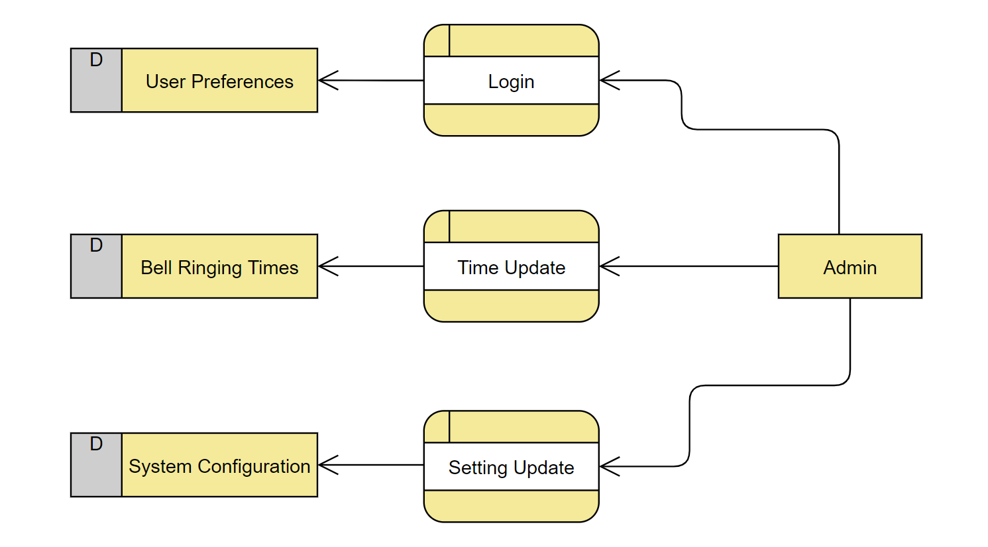

**3.3 Physical Design**

A database may be thought of as a set of related files. Related files mean that record of one file may be associated with the records in another file.

The conventional file based systems emphasized that the application and files were built around it. The database environment emphasizes the data independently of the applications that use the data.

The applications are allowed to evolve around a database design such that it can adapt to changing needs. Data becomes the central resource in the database environment.

Information systems are built around this central resource to give flexible access to data.

**3.4 Interface Design**

**3.4.1 Interface Designs**

This system contains various Forms, Buttons, Textboxes, Labels, and Picture boxes.

There are three types of interface design available. But we use tabs based interface (GUI). Because it has more advantages than other interfaces. Such as,

* Login
* Time Add/ Update
* Bell Configuration
* User Profile
* Easy to maintain
* Saving time wastage
* Speed of use

**3.4.2 Application Interfaces**

Application Interface of the automatic bell system is user friendly. Each interface has connected with API.

* A registered user Login his account on Login Page

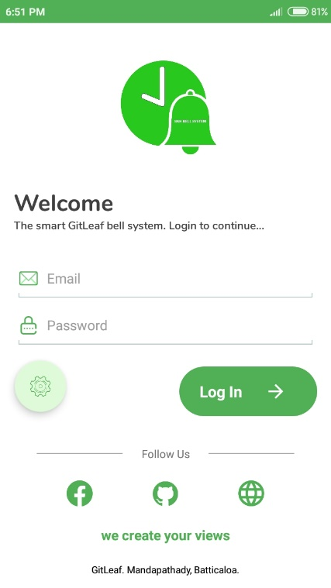

Picture 1: **Login Page**

* After login user can view the details of current bell ringing times.

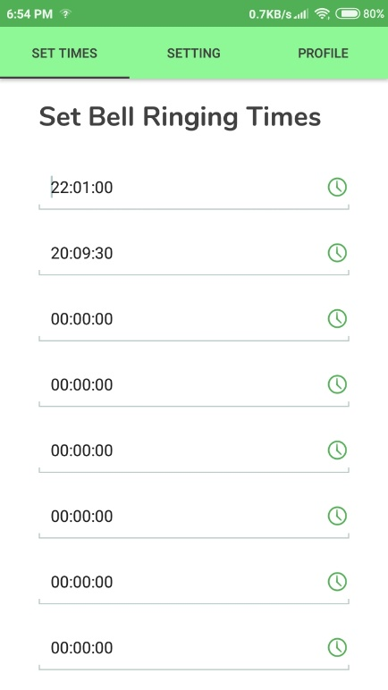

Picture 2: **List of bell ringing times**

* View more time adding fields and update button

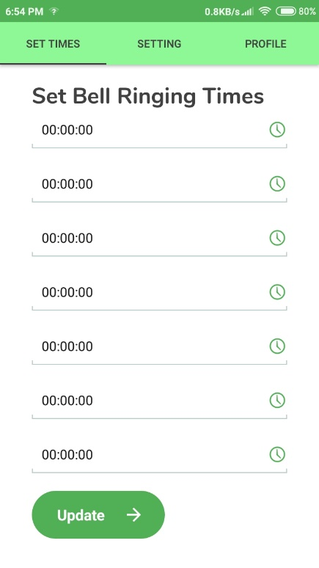

Picture 3: **More time fields and update button**

* User can configure bell system

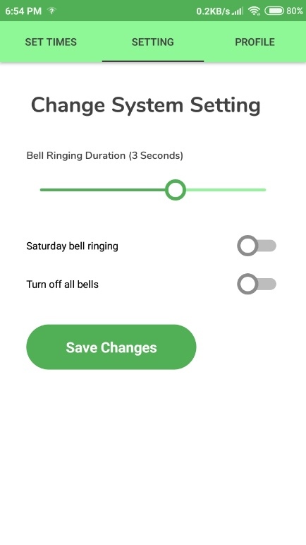

Picture 4: **Bell System Configuration**

* User can update their login details.

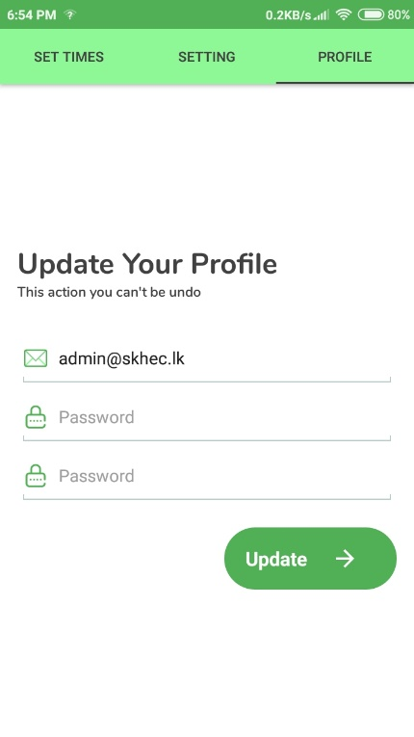

Picture 5: **User** **Profile Page**

**Chapter 4**

**SYSTEM IMPLEMENTATION**

Implementation is the stage in the project where the theoretical design is turned into a working system. The implementation phase constructs, installs and operates the new system. The most crucial stage in achieving a new successful system is that it will work efficiently and effectively.

There are several activities involved while implementing a new project.

* End user training
* End user Education
* Training on the application software
* System Design
* Parallel Run and To New System
* Post implementation Review

**4.1 End user Training**

The successful implementation of the new system will purely upon the involvement of the staff working in that school. The staff will be imparted the necessary training on the new technology

**4.2 End User Education**

The education of the end user start after the implementation and testing is over. When the system is found to be more difficult to understand and complex, more effort is put to educate the end user to make them aware of the system, giving them clarification about the new system and providing them necessary documents and materials about how the system can do this.

**4.3 Training of application software**

After providing the necessary basic training on the computer awareness, the users will have to be trained upon the new system such as the screen flows and screen design type of help on the screen, type of errors while entering the data, the corresponding validation check at each entry and the way to correct the data entered. It should then cover information needed by the specific user or group to use the system.

**4.4 Post Implementation View**

The department is planning a method to know the states of the past implementation process. For that regular meeting will be arranged by the concerned officers about the implementation problem and success

**Chapter 5**

**SOFTWARE TESTING**

Software testing is a critical element of software quality assurance and represent the ultimate review of specification, design, coding. The purpose of product testing is to verify and validate the various work products viz. units, integrated unit, final product to ensure that they meet their requirements.

Is the menu bar displayed in the appropriate contested some system related features included either in menus or tools? Do pull –Down menu operation and Tool-bars work properly? Is all menu function and pull-down sub function properly listed? Is it possible to invoke each menu function using logical assumptions that if all parts of the system are correct, the goal will be successfully achieved? In adequate testing or non-testing will leads to errors that may appear few months later.

This creates two problems:

* Time delay between the cause and appearance of the problem.
* The effect of the system errors on files and records within the system

The purpose of the system testing is to consider all the likely variations to which it will be suggested and push the systems to limits. The testing process focuses on the logical intervals of the software ensuring that all statements have been tested and on functional interval is conducting tests to uncover errors and ensure that defined input will produce actual results that agree with the required results. Program level testing, modules level testing integrated and carried out.

There are two major type of testing they are:

* White Box Testing.
* Black Box Testing.
  1. **White Box Testing**

White box sometimes called “Glass box testing” is a test case design uses the control structure of the procedural design to drive test case.

Using white box testing methods, the following tests were made on the system

All independent paths within a module have been exercised once. In my system, ensuring that case was selected and executed checked all case structures. The bugs that were prevailing in some part of the code where fixed

All logical decisions were checked for the truth and falsity of the values.

* 1. **Black box Testing**

Black box testing focuses on the functional requirements of the software. This is black box testing enables the software engineering to derive a set of input conditions that will fully exercise all functional requirements for a program. Black box testing is not an alternative to white box testing rather it is complementary approach that is likely to uncover a different class of errors that white box methods like.

* Interface errors
* Performance in data structure
* Performance errors
* Initializing and termination errors

**5.3 Scope of Testing**

In my project, I had first gone for “unit testing” strategy. In which I test for the functionality of each function, after that I performed “Integration testing” where I integrated them all and tested them together.

**5.4 Test Plan**

I have gone for unit testing and integral testing. So, I have initially concentrated on unit testing and for that I spend some time whenever I developed any new functions. This has been done during coding time as well as after the design whenever I use them.

After the completion of unit testing, I have moved to integration testing and I completed it in one day.

SDLC Phase Testing Activity:

* Requirement Review
* Design Review
* Implementation Code Review Unit Testing Component Testing Integration Testing
* Testing Robustness Compatibility Load Testing Security Regression
* Deployment/Maintenance Acceptance Testing Regressions

**5.5 Test case description**

|  |  |  |  |  |
| --- | --- | --- | --- | --- |
| Test | Test Cases | Expected response From System | Success | Priority |
| 1 | User tries blank input and to login | Notifies user that the user name or password is blank | Success | High |
| 2 | User provides invalid username or password | Notifies user that the user name or password is incorrect | Success | High |
| 3 | User click Wi-Fi button. | Provided shows turn on button to the user. | Success | High |
| 4 | New user input details with invalid email address and details | Form validation displays errors in relevant fields. System rejects input | Success | High |
| 5 | Update time with blank details | Form validation displays errors in relevant fields. System rejects input | Success | High |
| 6 | Validate user password with confirm password field | If both password and confirm passwords are similar user can proceed | Success | High |

**5.6 Validations**

No record can be saved till all the necessary entries are done.

Only administrator can perform sophisticated tasks like printing of Reports, Register new member and/or delete an existing member etc.

For security purposes the E-mail of user is required in case he/she forgets his/her password and wants to retrieve that.

**5.7 System Security Measures**

Security prompting the user for a user-id and password in our application is a potential security threat. So credential information is transferred from the browser to server are encrypted.

Security features are implemented. No unauthorized access the package, as the security is implemented through login and password.

**Chapter 6**

**DATABASE MANAGEMENT**

**6.1 Database Management System**

A database is a collection of interrelated data stored with minimum redundancy to serve many users quickly and effectively. After designing input and output, the analyst must concentrate on database design or how data should be organized around user requirements. The general objective is to make information access, easy quick, inexpensive and flexible for other users. During database design, the following objectives are concerned: -

* Controlled Redundancy
* Data independence
* Accurate and integrating
* More information at low cost
* Privacy and security
* Performance
* Data backup and recovery
* Ease of learning and use

**6.2 Database Backup**

Database backup is the process of backing up the operational state, architecture and stored data of database software.it enables the creation of a duplicate instance or copy of a database in case the primary database crashes is corrupted or is lost.

**6.2.1 Backup Data**

Backup means to [copy](http://www.webopedia.com/TERM/C/copy.html) [files](http://www.webopedia.com/TERM/F/file.html) to a second [medium](http://www.webopedia.com/TERM/M/media.html) (a [disk](http://www.webopedia.com/TERM/D/disk.html) or [tape)](http://www.webopedia.com/TERM/T/tape.html) as a precaution in case the first medium fails. So, the database has day-to-day backup to saves the data from the database. Therefore, we got your backups on your smart phone. That backup will be reused by the programmer if the database going to destroyed.

**6.2.2 Backup Media**

Backup can be JSON format

**Chapter 7**

**CRITICAL APPRAISAL OF PROJECT**

**7.1 Review of the Project Development Process**

Software peer reviews are conducted by me and my colleagues, to evaluate the Technical content and quality of the product.

**7.2 Strengths and Weaknesses**

**7.2.1 Strengths**

* Automatic Bell System has graphical user interfaces (GUI) to communicate with users.
* GUIs’ are made as user friendly.
* Security of the user is high.
* It is made for easy to handle.

**7.2.2 Weaknesses**

* If there is a power failure while ringing bell stopped.
* No auto backup and online backup option available, all information will be losing in case of automatic bell system hardware damaged.

**7.3 Future Scope and further enhancement of the Project**

**7.3.1 Future Scope**

The project automatic bell system for School is flexible enough to meet the requirements of the School staffs. This project also has the scope of enhancements like:

* Centralized database use
* Auto backup to the web

**7.3.2 Further Enhancement of the Project**

Everything that is made has some or the other things to be added to make it better than revolutions.

The project “Automatic bell system”, it has been tried to develop a robust and fault free system, still enough flexibility has been provided for further enhancements and modifications. As I mentioned earlier then the designed forms are typically reflections of the developer, so I strongly believe that the enhancement to be done with the project to be done with the design changes, coding changes. But at the same time I would like to mention that since one cannot claim himself as a master of the technology there is always some scope of technical modifications in the project that may lead to find code redundancy &storage space minimization.

Since the data is retrieved from the tables where everything is based on the coding system if the coding system is changed then the system needs to be redesigned.

**Chapter 8**

**CONCLUSION**

**8.1 Conclusion**

It has been a matter of immense pleasure, honor and challenge to have this opportunity from Kannankudah Maha Vidyalaya to take up this project and complete it successfully. While developing this project I have learned a lot about School management, I have also learned how to make it user friendly (easy to use and handle) by hiding the complicated parts of it from the users. During the development process, I studied carefully and understood the criteria for making software more demanding, I also realized the importance of maintaining a minimal margin for error.

**8.2 Bibliography**

* <https://www.arduino.cc>
* <https://developer.android.com/about>
* <https://www.postman.com/>
* <https://simple-circuit.com/nodemcu-ds3231-ssd1306-rtc/>

**8.3 Reference**

* “Arduino Developers,” Arduino. [Online]. Available: https://www.arduino.cc/. [Accessed: 20- Feb-2020].
* “Android Developers,” Android Developers. [Online]. Available: https://developer.android.com/. [Accessed: 20-Feb-2020].
* “An open-source firmware based on ESP8266 wifi-soc.,” NodeMcu. [Online]. Available: https://www.nodemcu.com/index_en.html. [Accessed: 20-Feb-2020].
* “The Collaboration Platform for API Development,” Postman. [Online]. Available: https://www.postman.com/. [Accessed: 20-Feb-2020].
* “Real time clock using NodeMCU, DS3231 and SSD1306 OLED,” Simple Projects, 27-Aug2018. [Online]. Available: https://simple-circuit.com/nodemcu-ds3231-ssd1306-rtc/. [Accessed: 20-Feb-2020].